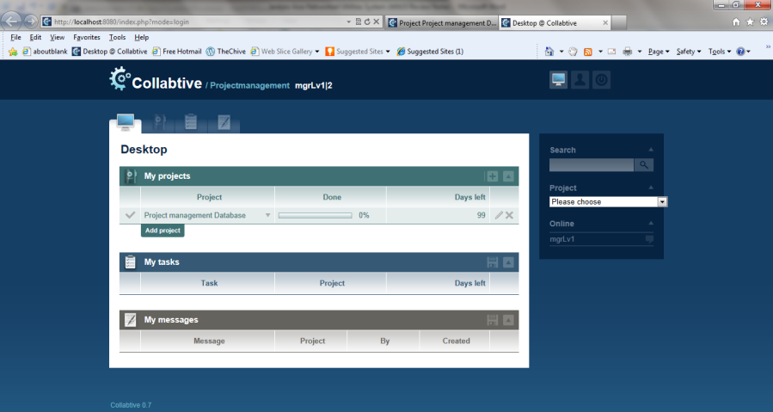

* Change Collabtive Name and Logo to Jenkins Asia Logo and Name. Database name to be changed to Jenkins Asia Networked Utilities System (JANUS)

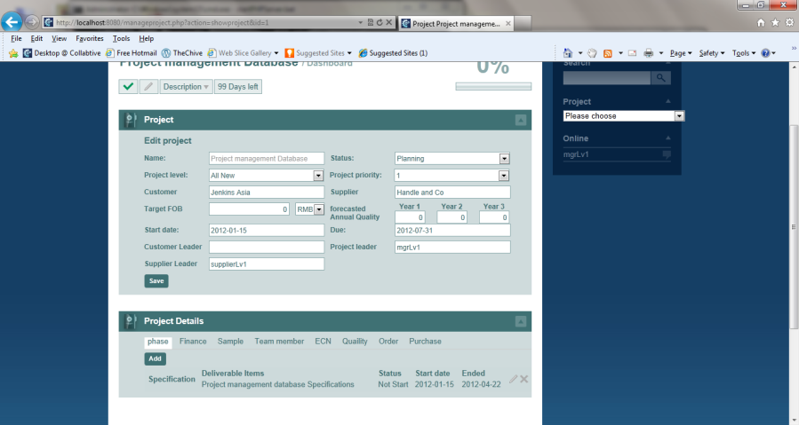

* Project page or Project window should also have [Attach File] Button.
* Add field for “Project Number”

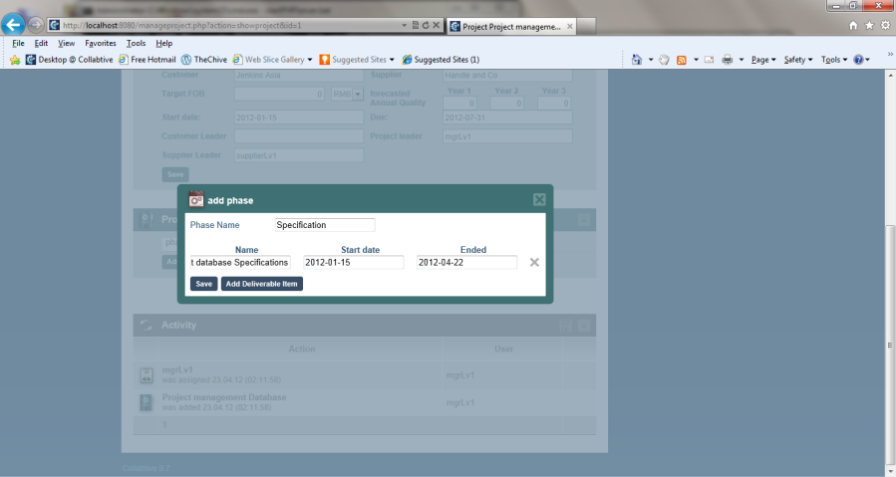

* Add [Attach File] button
* Also, add [Parent Phase] drop down box. Add [Child Phase] drop down box. Allow – “None” as an option

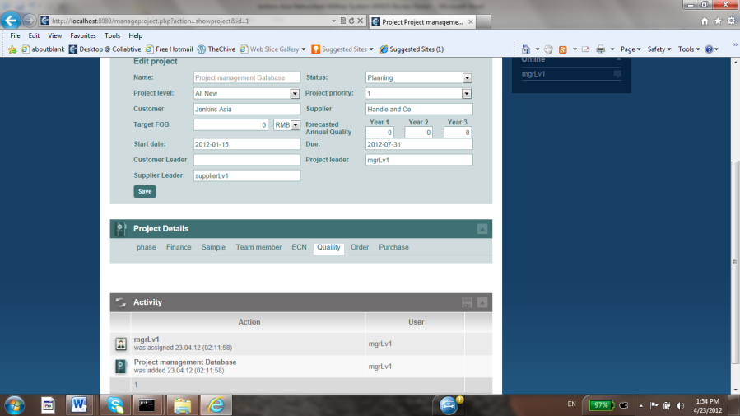

* “Quality” should be spelled correctly
* The fields should follow JKT-01 form
* There should also be a main Quality page that summarizes all the quality issues that are entered, tracked by Week, Month, Year, Customer. This can be seen in the Project management Database Notes. The quality page should be seen from across all Projects and not just one project. This is similar to the Quality – Supplier Scorecard

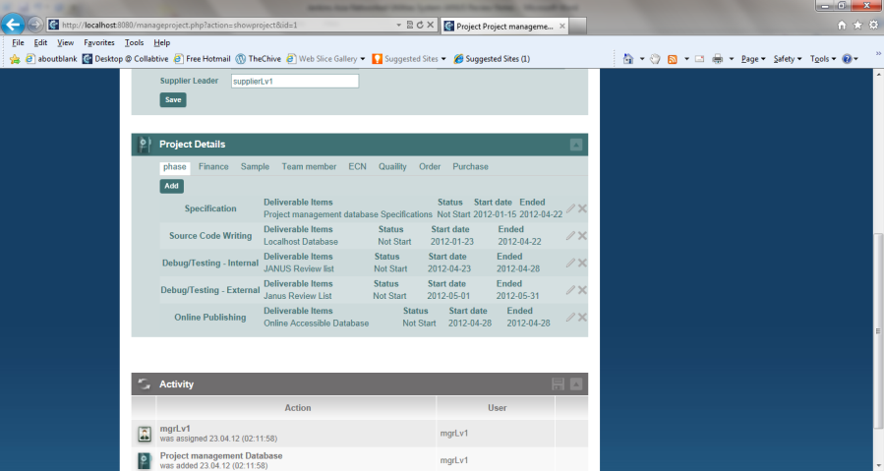

* Ability to sort phases or tasks based on time and if there is Parent Child link, the phases should be listed chronologically.

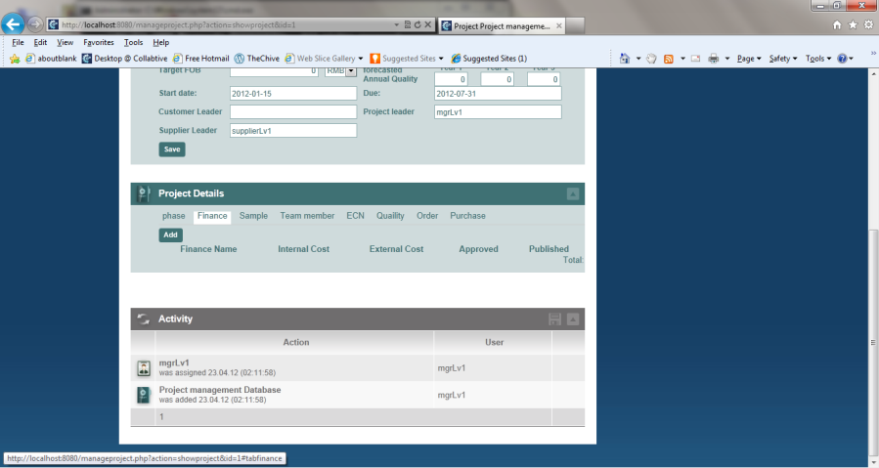

* The Finance tab should be listed at “Costing” and the fields are not the same as the Project Management Database Notes at all.
* Please note that costing should have internal and external cost fields per the Project Management Database Notes
* Also, there is a financial tracking module which tracks financial transactions across all projects and customers

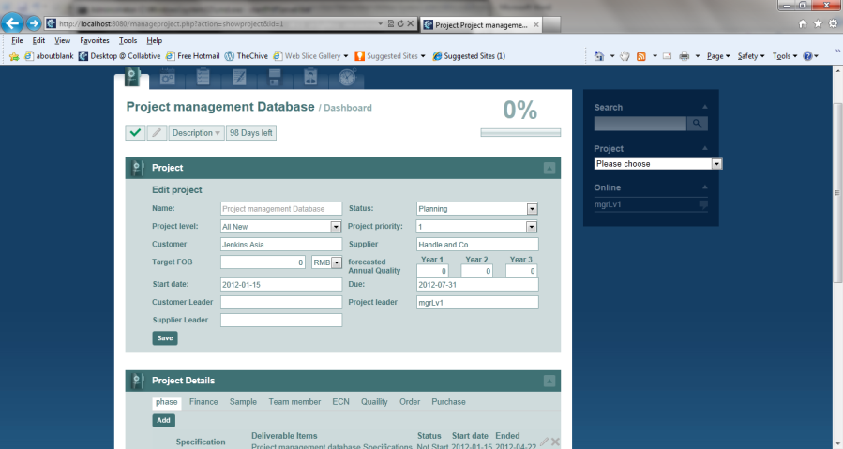

* Can there be a document tab here that links to the files tab?
* Once the document is attached and approved, the document cannot be edited, only a new document with a new revision can be attached.
* Also, there should be main documents page and main ECR/ECN page that captures ECRs/ECNs across all projects and customers
* See Project management Database Notes for details on ECR and ECN

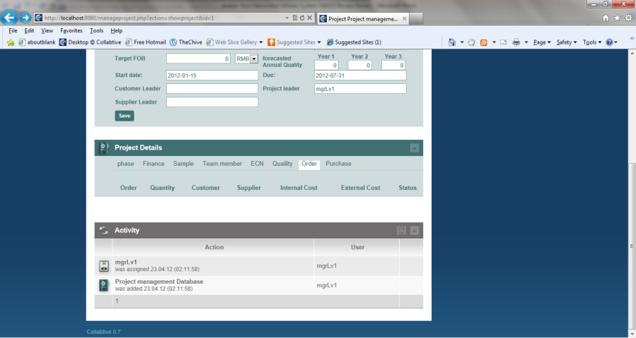

* Order tracking has missing fields
* Also, there should be a main order tracking page that tracks all orders from all customers and projects and not just one project.